**LID-DRIVEN CAVITY**

Validate domain with lid-driven cavity with respect to analytical and also at various sides of the domain to evaluate side and signs of boundary conditions (up to 10s for reference case at Re = 100 (Ghia et al. 1982)).

1. **Standard at 50x50**

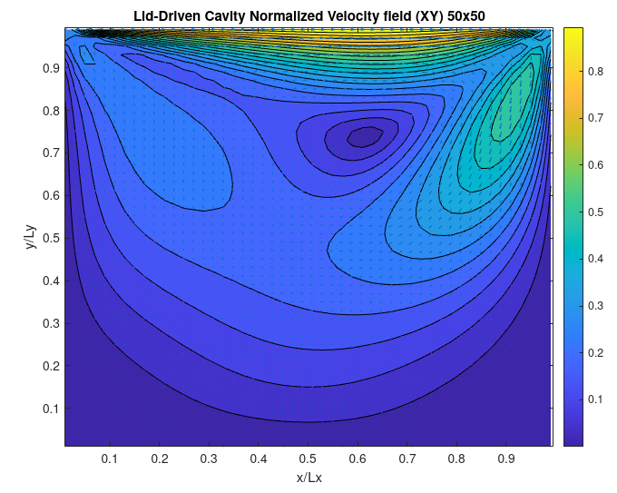

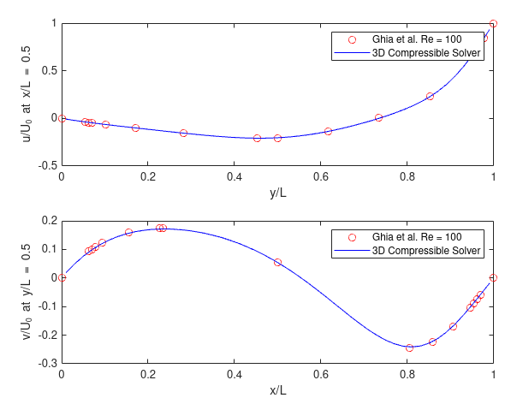

1. **North - South swap (u - symmetry and v - -ve)**

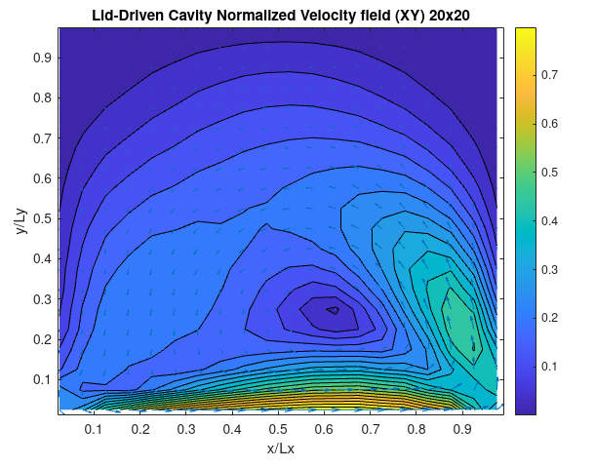

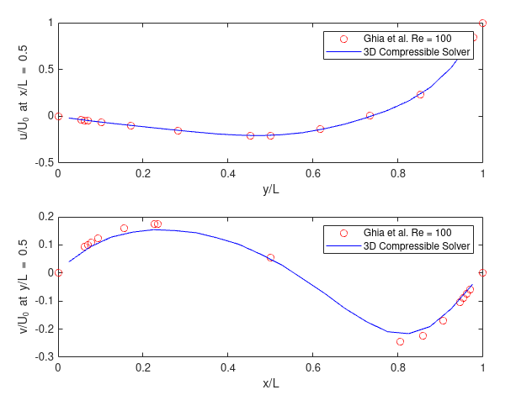

1. **East at v = 1**

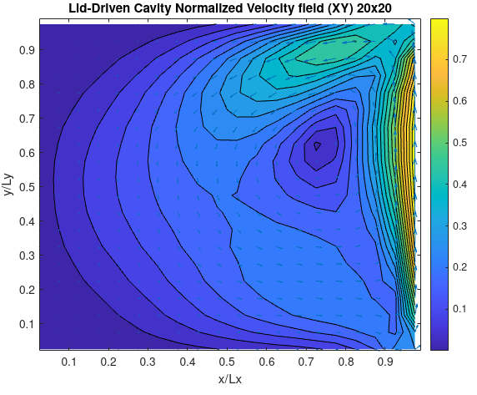

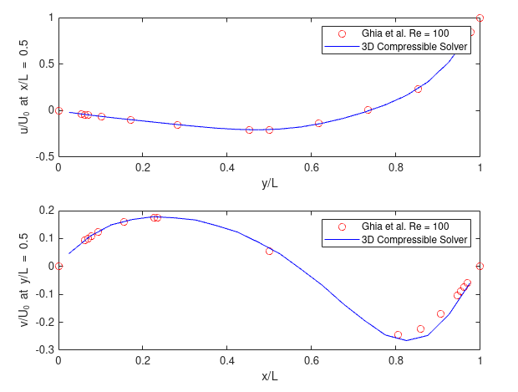

1. **West at v = 1**

